**Assignment 02**

**Hadoop Cluster with single Node**

Name: Puja Kawale

SJSUID: 0125-06156

Date: 10/06/2018

**Reference:** [**https://hadoop.apache.org/docs/r3.0.3/hadoop-project-dist/hadoop-common/SingleCluster.html**](https://hadoop.apache.org/docs/r3.0.3/hadoop-project-dist/hadoop-common/SingleCluster.html)

**Screenshots:**

1. **Nodes started:**

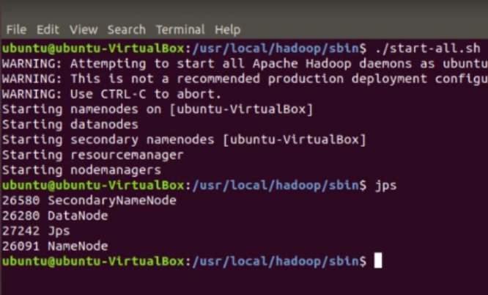

**Sample App :**

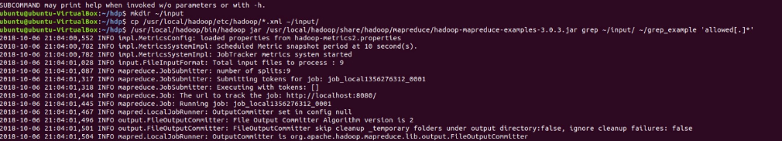

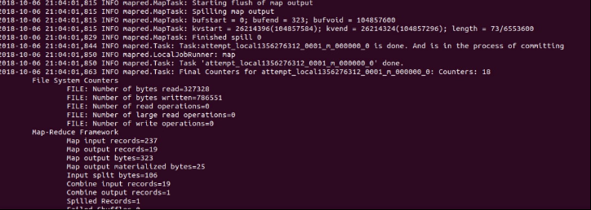

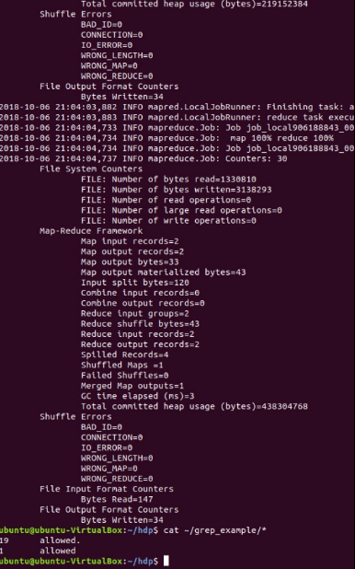

1. **ON AWS_Ec2 Ubuntu:**

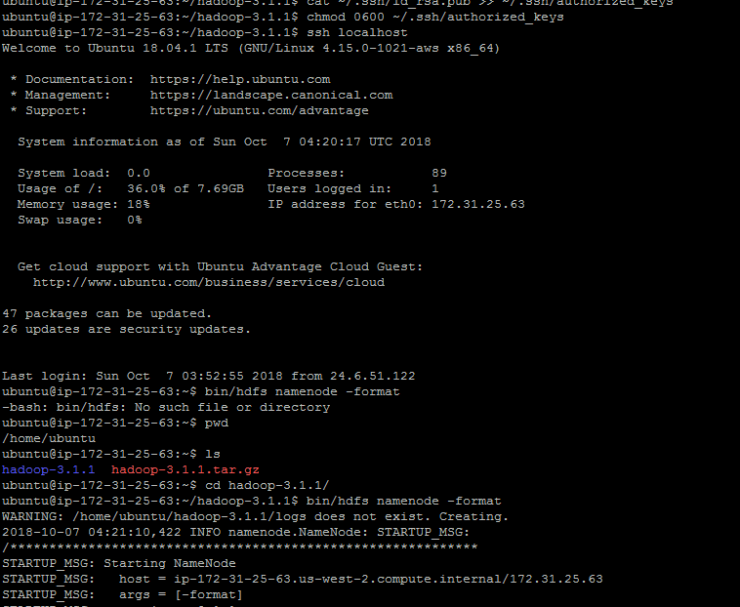

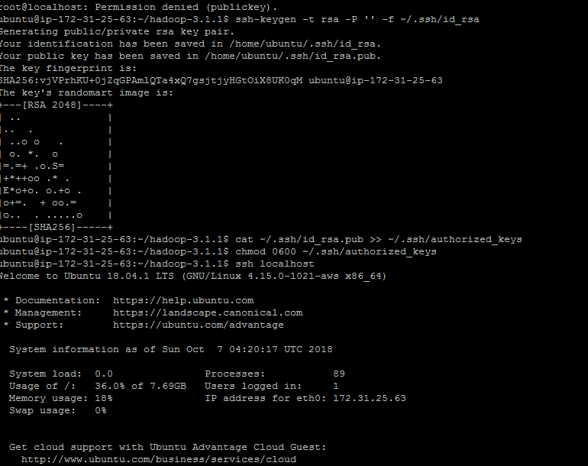

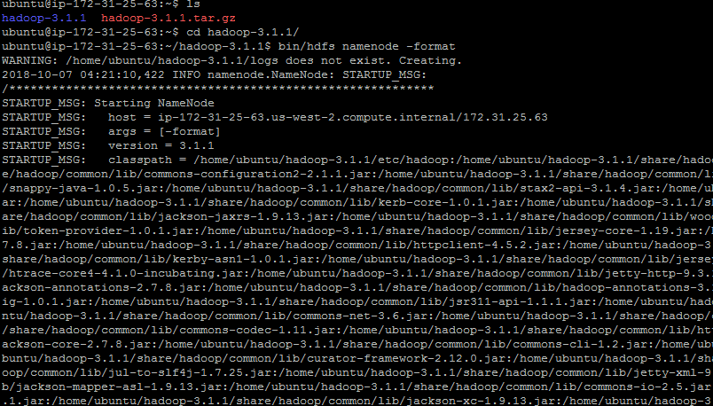

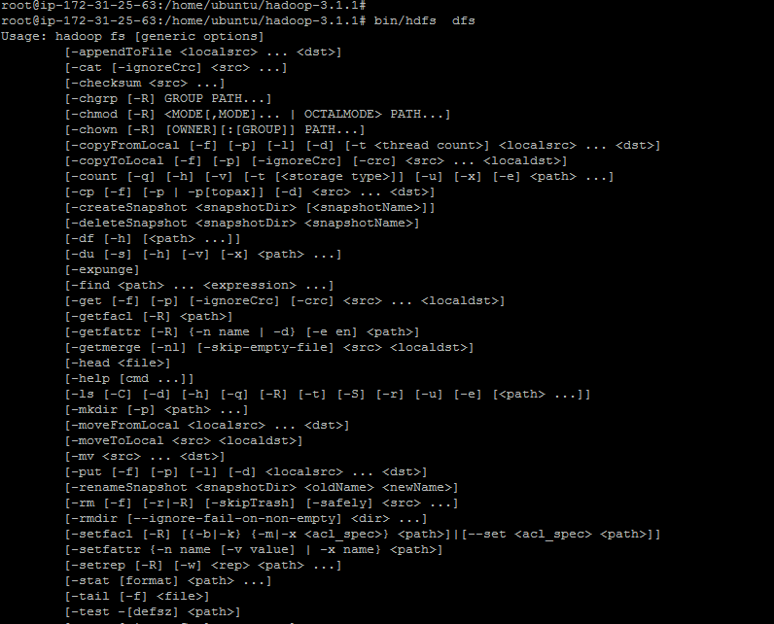

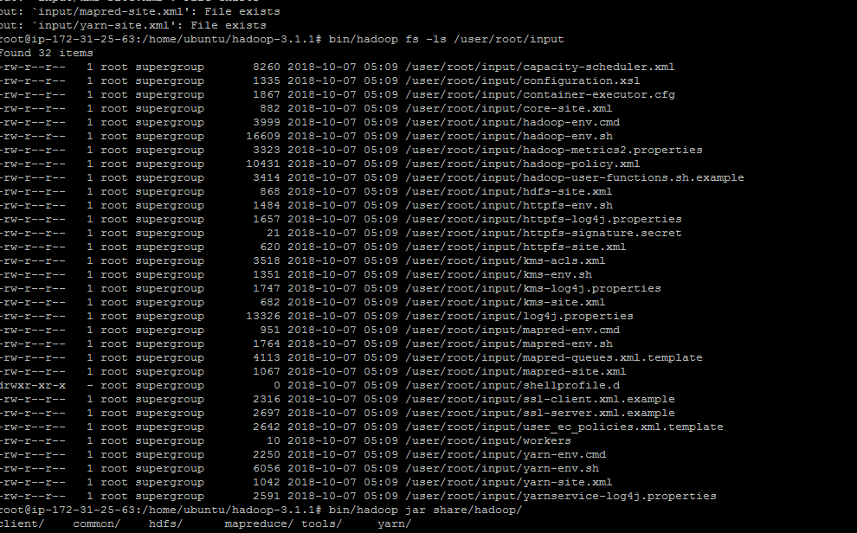

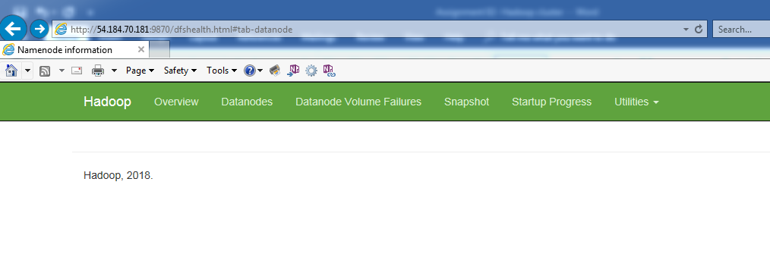

1. **AWS EMR**

